**PARALLEL AND DISTRIBUTED COMPUTING**

**LAB 3 (20K0155)**

**QUES 1**

**1- Parallel :**

**It is used to create multiple openmp threads, which execute the region parallelly, each thread executing some part of region.**

**2- Single/Master :**

**Single clause specifies that the associated block would only be executed by a single thread(not necessarily the master thread)**

**While Master clause specifies that the associated block would only be executed by master thread.**

**3- Atomic/Critical :**

**Critical clause restricts the execution of the associated block with a single thread at time.**

**4- Reduction :**

**Perform reduction on the scaler variables that are included in the variable-list with the operator.**

**5- OpenMP API calls :**

**These are used to call OpenMP API runtime library routines.**

**QUES 2**

**Task Parallelism(task1)**

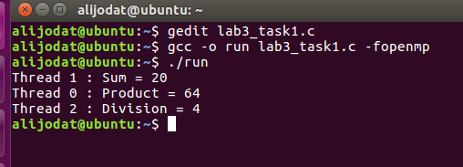

**Data Parallelism(task2)**

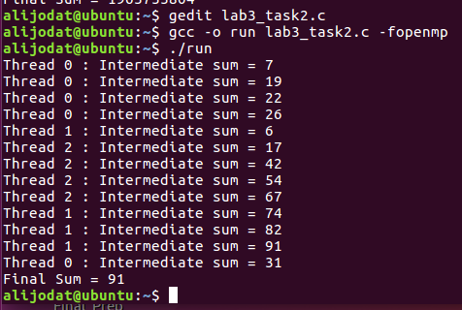

**QUES 3**

**Syntax for dynamic and static scheduling :**

**#pragma omp parallel for scheduling(dynamic,chunck_size)**

**#pragma omp parallel for scheduling(static,chunck_size)**

**Ans : Yes! Chunk size can be used to specify granularity as it defines how many iterations or tasks would be performed by each thread. If chunk size is large,it would be course grain. And if chunk size is small, it would result in fine grain.**

**QUES 4 (task3)**

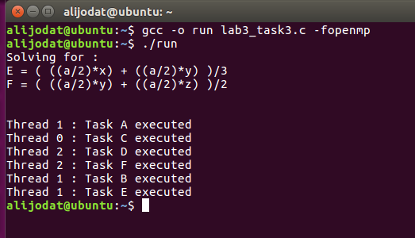

**QUES 5 (task4)**

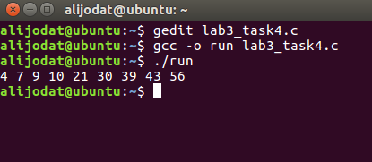

**QUES 6 (task5)**

